Appendix 1 - Tenant Involvement and Empowerment Mini Review – Action Plan Update

Recommendation | Timelines | Progress – to July 2023
- That the Council identifies appropriate thresholds above which procurement or interview-focused ambassadors will be invited to be involved in the respective process. | Implementation April 2023 | Procurement:  The recommendation has been agreed with the Council’s Procurement team and implementation commenced with the Social Housing Decarbonisation Fund Programme:  - Identification of threshold level of engagement – contracts within housing revenue account areas with the threshold to be subject to review.  - Ambassadors to review social value segment contract – quantified as 10% overall scoring on award.  - Ambassadors do not have sight of the financial or technical elements of the contract tender bids.  - Ambassadors receive feedback on successful contractor and to attend contract management meetings where appropriate.  Recruitment:  - Ambassadors to be part of a stakeholder panel for any permanent Landlord Services role for a team leader or manager role up to and including Head of Service.
- That the Council establishes a board with Cabinet member, senior officers and tenant and leaseholder representatives to meet on a regular basis to discuss tenant and leaseholder issues, and to report on progress and performance. | Nov 2023 | An initial proposal has been drafted however there are still some difficult issues that remain outstanding including remuneration of residents and the ability to recruit and retain sufficient interest.  Next Steps:  - Provide full proposal for a tenant and leaseholder Board, an action plan, timeline, and Terms of Reference to Head of Service for agreement and sign off  - Terms of Reference to be agreed with Ambassadors  - Recruitment campaign to commence from October 2023
- That the Council makes the greatest effort to ensure that tenant representatives on the board reflect the geographic and demographic diversity of the Council’s tenants. | April 2023  July 2023 | A mapping exercise has been completed on new and existing Ambassadors:  Age Ambassadors  18-35 1  36-45 4  46-55 11  56-65 9  66-75 8  76-85 3  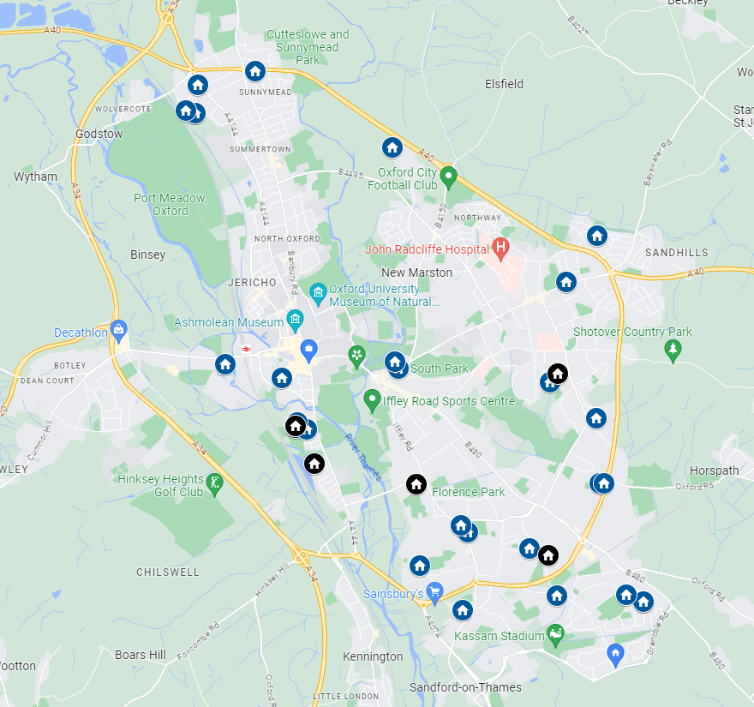  A recruitment and community engagement programme is ongoing. We are:  - advertising in Tenants in Touch  - meetings with faith group leaders  - talking with Locality Managers, Tenancy Management Officers  - making use of the Resident Liaison Co-ordinators and Building Safety Resident Engagement Officer to improve our visibility  - STAR survey provided 10 volunteers to attend induction meetings and five new Ambassadors recruited.
- That the Council establishes the planned Housing Development Working Group as a matter of priority, that it includes within its scope issues relating to interior design of the homes built, and that a more precise name is agreed. | Underway | Ambassadors are:  - Reviewing new build designs with OX Place  - Reviewing new build communal areas and management standards.  - Engagement Day between teams booked for August.
- That the Council implements ways to recognise the contributions of tenant ambassadors which do not incur universal credit clawback or other benefit issues. | In Place | All larger scale survey/meetings recognise and award participation with prizes. A recent survey to review the tenant in touch magazine process awarded three participants:  - Air Frier  - £100 voucher  - £50 voucher
- That the Council recruits more tenant ambassadors from younger age groups, particularly to participate in the Housing Development Working Group and Great Estates | Ongoing | We have been working with resident Ambassadors to identify and target younger tenants to join however this is challenging. Further effort to include promotion when the digital edition of Tenants in Touch is launched (1st Edition delivered 21/7) - more likely to attract younger people.  Further recruitment efforts to take place with new tenants at the six-week welcome visits carried out by Tenancy Management.  As part of the Landlord Services Transformation work, younger tenants will be targeted for engagement activities, linked in with digital channel shift (Customer Portal, Localz, digital Tenants in Touch, promoted through a variety of media).
- That the Council recruits a tenant ambassador to represent the views of older, frailer residents. | Achieved and in place | The representation is in place and recommendation achieved – see response to recommendation 3.
- That the Council interrogates the data at ward-level from the census (when available), and the tenant satisfaction survey, alongside the knowledge of locality workers to develop a profile of the specific needs of each ward, and that this is shared with members and used to identify priorities for work planning at community level. | Project ongoing. | The Council’s Business Improvement Team have been approached to carry out cross-tabular analysis on the findings between census data and the STAR survey. Results are expected autumn 2023.  Locality Managers have been approached to ask for their views of the priorities of their areas, noting that wards and locality patches are not coterminous.
- That the Council works to develop a distinct Housing identity. | Ongoing | This is being reviewed as part of the ongoing Landlord Services Transformation work, which will involve improved communication with tenants and members and greater publicity of the service and the work that is carried out by staff.
- That the Council ceases to make reference to ‘customers’ or ‘clients’ in its reports unless the relationship is genuinely commercial. | Ongoing | Wherever appropriate tenants and leaseholders will be referred to as such in reports although noting the Council’s preference for the use of the word, “citizens”.
- That in the event that the Tenants Forum established by the DSS discrimination motion does decide not to pursue a joint Council and private rented sector structure, that the Council ensures that a Council Tenants Forum continues to be provided. | Paused | At its meeting of 13 March 2023, the Head of Regulatory Services and Community Safety provided an update to the Housing and Homelessness Panel, advising that setting up of the Forum would be paused until enforcement action in regard to selective licensing of private landlords had begun.  Should this prove to not be viable then the Tenant Involvement team will pursue the available options.
- That the Council prioritises the collection of the KPIs required for distribution by the Social Housing white paper. | In place and underway | KPIs are being collected via the Project Lead on the Social Housing White Paper.  - A Project Tracker has been created to manage OCC’s progress.  - SHWP (Social Housing White Paper) Task & Finish Group holds monthly meetings.  - Tenant Satisfaction Measures (TSMs) will provide first official benchmarking data with other social landlords. Although there is only a requirement to start providing this annual data to RSH (Regulator of Social Housing) from spring 2024, the council is already collating data. This data will be published on our website in autumn 2023.  - The RSH (Regulator of Social housing) will be publishing all TSM data themselves starting summer 2024, as a benchmark across eligible (1000 homes and above) social landlords  - ODS’ (Oxford Direct Services) new repair transactional software called Localz has been launched, which includes transactional satisfaction surveys on two of the TSMs  - A new Landlord Service Performance webpage on our website will be designed and then populated with the above information.
- That the Council publishes, in addition to the annual report required by the Social Housing white paper, live performance data on its website, and distributes performance details to tenants in each Tenants in Touch magazine. | By April 2024 | - The STAR survey results 2022 have been publicised with a press release on the Council’s website and will also be shared via Tenants in Touch and the Annual Report to tenants.  - Work has commenced to develop STAR survey 2023 continuing work with Acuity as our external contractor  - A PowerBI specialist has been recruited to create live performance dashboards that will enable real time performance information to be published on the Council’s website as well as improving overall performance visibility for managers.
- That in its reporting against Social Housing white paper KPIs the Council benchmarks against relevant comparators. | In place | We will benchmark against comparators when the data is published (expected summer 2024)
- That the Council reviews whether the structures to enable tenants to challenge areas of spend under the Social Housing white paper are sufficient to give tenants meaningful challenge to Council spending. | In place and ongoing | Challenge opportunities:  - Training on Housing Revenue Budget and budget consultation process  - Video training by Finance Business Partner  - Monthly training programme ongoing for all Ambassadors  - HRA challenge date set for Ambassadors
- That the Council implements and promotes a clearer process for councillors and tenants to influence the spending of the Great Estates programme. | Under review | The Great Estates project is currently being reviewed.
- That the Council implements a councillor casework system for housing issues within QL within 12 months | In progress | The Council is currently evaluating which software system would be the most effective. The intention is to utilise one of two existing systems. Our aim is to start with a pilot of Members in the autumn.
- That the Council holds discussions with Thames Valley Police to determine whether additional resources for community policing have become available, and to propose reinstating Neighbourhood Action Groups or similar ward-based stakeholder meetings in priority areas if so. | Ongoing | There is an agreement across partners that Neighbourhood Action Groups are not the most effective way to achieve joint working.  Neighbourhood policing has numerous competing demands on resources, reducing officers available. ASBIT continues to work closely with TVP to prevent and tackle ASB within local areas.  Joint working highlights include:  - A multi-agency group has been formed in Barton, providing targeted work with young people and the wider community.  - A successful knife sweep was carried out.  - Deployable CCTV in use. Advice also given to partners on appropriate and legal use of CCTV.
- That the Council undertakes preparatory work with the Police to enable joint working at a locality level to be established as quickly as possible. | In place | This recommendation is accepted and is ongoing. Our best practical examples include:  - Joint multi agency knife sweep teams  - Joint community engagement work  - Joint CCTV deployment arrangements  - Joint walkabouts and problem-solving meetings

